# Requirements Specification for an Ultrasonic Wayfinder

## Specification

System Description

The design specification describes an implementation of an ultrasonic-range-finding device that utilizes haptic feedback to alert its user about obstacle in his path. The device is a combination of several ultrasonic transmitter/receiver circuits capable of emitting short pulses of ultrasonic-frequency sound. The receiver picks up the echoed pulses. The time delay between the emission of the initial pulse and the receipt of the echo gives the system the necessary data to determine how far away the obstacle(s) is from the sensor, which can be described to the user by vibrating a small motor at the intensity proportional to the distance. This gives the user a sense of special recognition in almost all kind of environment. This project is purposed as a proof-of-concept for a product that can be used by sight-impaired individuals to detect obstructions.

Specification of External Environment

The system is designed to operate in any environment. But its main purpose is to help the user navigate spaces with obstacles in their paths. Since the system utilizes ultrasonic echolocation to provide the user the ability to navigate close spaces, it works best when the ultrasonic waveforms are not be interrupted by other potential interferences in the general vicinity. Therefore, the amount of such way finding devices that can operate within the same space is limited. This is not a major concern in designing the system since it’s fairly rare for multiple people who require the assistance of such a system to be in the same closed space at once. The system is powered by a 9V battery; therefore, it does not depend on an immobile power system. But to ensure an uninterrupted working condition, the user should consider carrying a backup battery.

System Input and Output Specification

Inputs

The system supports the following basic inputs from the user:

* + - * Power on [User controlled] – On condition for the system
      * Power off [User controlled] – Off condition for the system
      * Intensity HIGH [User controlled]– Specifies a higher intensity vibration proportional to the distance from the obstacles.
      * Intensity LOW [User controlled]– Specifies a lower intensity vibration proportional to the distance from the obstacles.

The internal system input, which does not rely on user specification:

* Echoed Signal [Internal system] – The input needed to determined the distance from the obstacles

Outputs

The system main outputs are the haptic feedback provided to the user:

* Vibration left – Left motor vibration to indicate obstacle on the left side.
* Vibration right – Right motor vibration to indicate obstacle on the right side.
* Vibration hand – Hand-attached motor vibration to indicate obstacle in the direction pointed to by the user
* Battery low sound – A voice notification is provided to the user via a headphone output to indicate low battery condition

The internal system output, which does not rely on user specification:

* Transmitted Signal [Internal system] – The output from the system to echolocate the closest obstacles

User Interface

The user has control of three mechanical buttons:

* + - On button – Allows the user to turn the system on
    - Off button – Allows the user to turn the system off
    - Toggle intensity – Changes between HIGH and LOW intensity level

All outputs of the system will be in the form of haptic feedback or audio responses

* Vibration left
* Vibration right
* Vibration hand
* Battery low indication (audio)

System Functional Specification

The ultrasonic wayfinder is intended to allow the user the ability to navigate close spaces without the dependency on the heavier equipment such as the white cane. The system also gives the user a sense of spatial awareness that the traditional cane was not able to. The control of the system is relatively simple as the only task the user is required to do is equipping the necessary items, then turn on the system. The user has the ability to choose the vibration intensity to match his preference.

The output of the system includes haptic feedbacks to the three motors; the conditions and intensities of these feedbacks correspond to the environment in which the system is used. For example, if there exists an obstacle such as a wall about 35 degree and 1 foot away from the user, the left motor would vibrate at full intensity while the right motor stays idle. Correspondingly, if the obstacle is straight ahead and 1 foot away, both motor would vibrate at near-full intensity.

The hand-mounted motor vibrates whenever the user points their hand-mounted sensor at a nearby object. This hand-mounted device represents the traditional cane, but it is less wieldy and it offers the user more spatial awareness. While the two main head-mounted sensors are more like seeing eyes, giving the user the ability to recognize obstacles ~60 degrees in front.

Operating Specifications

The system will be expected operate in a standard commercial environment. In the cases of harsh weather such as rain, snow, or other extremities, the system is not expected to operate due to the nature of it being an electronic device. A weather proof prototype may be developed in the future if the product performs exceedingly well in the initial development phase.

Temperature range

* 20 – 80°C

Humidity

* 20 – 60% non condensing

Pressure

* 1 atmosphere

Power

* 9 VDC

Use Case

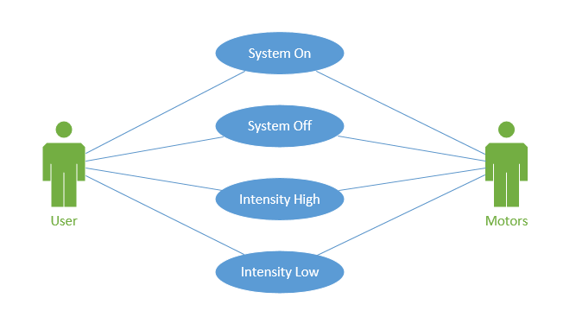

System On:

Power the system on

Exception: No power supply, battery dead.

System Off:

Turn the system off

Exception: System is already off

Intensity High:

Toggle the intensity mode to high

Exception: No battery. System off

Intensity Low:

Toggle intensity mode to low

Exception: No battery. System off.